**Cognitive Walkthrough Report**

1). Pre-preparation:

Users:

1. Students who are wishing to learn and
2. Teachers who are wishing to teach sorting algorithms through the game

User Category: The users have been classified into the categories Novice, Intermediate and Experts based on their age groups as tabulated below:

|  |  |
| --- | --- |
| **User Academic Level** | **User Category** |
| Primary School | Novice |
| Secondary School | Intermediate |
| College Undergraduates | Experts |

Tasks for Evaluation:

* Evaluation for “Learning Bubble Sort by playing the game”
* Evaluation for “Learning Insertion Sort by playing the game”
* Evaluation for “Learning Selection Sort by playing the game”
* Evaluation for “Learning Radix Sort by playing the game”
* Evaluation for “Checking the highest score”
* Evaluation for “Increasing/decreasing the game sound”

**1) Action Sequences:**

Task – 1: Learning Bubble Sort by playing the game

A1: Activate the app interface by pressing the app icon

R1: Launch the app and display the main menu

A2: Press the SETTINGS button and then the “how to play” button within it to learn

to play the game and the game moves

R2: Opens an interactive tutorial involving the user which teaches him to play the game

A3: Press PLAY BUBBLE SORT button to start playing the game.

R3: Start the Bubble Sort game

A4: Select a pair of cubes and swap them according to the Bubble sort algorithm

R4: Swap the cubes selected

A5: Press the Evaluate button to check the configuration after each iteration of the outer loop and keep doing this until the game is finished

R5: Evaluate the submitted configuration (i.e. , assign score for the submitted configuration)

Task – 2: Learning Selection Sort by playing the game

A1: Activate the app interface by pressing the app icon

R1: Launch the app and display the main menu

A2: Press the SETTINGS button and then the “how to play” button within it to learn

to play the game and the game moves

R2: Open an interactive tutorial involving the user which teaches him to play the game

A4: Press PLAY SELECTION SORT button to start playing the game

R4: Start the Selection Sort game

A5: Select a pair of cubes and swap them according to the Selection sort algorithm

R5: Swap the cubes selected

A6: Press the Evaluate button to check the configuration after each iteration of the outer loop and keep doing this until the game is finished

R6: Evaluate the submitted configuration

Task – 3: Learning Insertion by playing the game

A1: Activate the app interface by pressing the app icon

R1: Launch the app and display the main menu

A2: Press the SETTINGS button and then the “how to play” button within it to learn

to play the game and the game moves

R2: Open an interactive tutorial involving the user which teaches him to play the game

A4: Press PLAY Insertion SORT button to start playing the game

R4: Start the Insertion Sort game

A5: Select a cube and remove it from the list and place it correctly as per the Insertion sort algorithm into the list

R5: Swap the cubes selected

A6: Press the Evaluate button to check the configuration at the end of outer loop and keep doing this until game is finished

R6: Evaluate the submitted configuration

Task – 4: Learning Radix sort by playing the game

A1: Activate the app interface by pressing the app icon

R1: Launch the app and display the main menu

A2: Press the SETTINGS button and then the “how to play” button within it to learn

to play the game and the game moves

R2: Open an interactive tutorial involving the user which teaches him to play the game

A4: Press PLAY RADIX SORT button to start playing the game

R4: Start the Radix Sort game

A5: Select a cube and remove it from the list and place it correctly as per the Radix sort algorithm into the list

R5: Swap the cubes selected

A6: Press the Evaluate button to check the configuration at the end of outer loop and keep doing this until game is finished

R6: Evaluate the submitted configuration

Task – 5: Checking the highest score

A1: Activate the app interface by pressing the app icon

R1: Launch the app and display the main menu

A2: Press the LEADERBOARD button to see the top 5 highest scores

R2: Open an interactive tutorial involving the user which teaches him to play the game

Task – 6: Increasing/decreasing the game sound

A1: Activate the app interface by pressing the app icon

R1: Launch the app and display the main menu

A2: Press the SETTINGS button and repeatedly press the increase/decrease volume button to increase/decrease the game sound.

R2: Open an interactive tutorial involving the user which teaches him to play the game

* *The questions asked in the interview are exhaustive:*

The questions asked in the interview are exhaustive since:

* The user may either try to achieve the end goal or give up before the game ends (covered in Question 1)
  + - * + If the user continues, then he may or may not notice the correct action choices are available (covered in Question 2)

If the user notices the correct action, he will take that action and may or may not be completely confident about it (covered in Question 3)

If he takes that action, he would be given feedback for the action he takes, which he may or may not understand (covered in Question 4)

If he understands the feedback, he may or may not complete the task with satisfaction (covered in Question 5)

Since these questions cover all the possible situations that a user may go through while executing the system, they are exhaustive.

* *The Tasks are representative:*

The set of all functionalities supported by the system are sorting each of the four algorithms (Tasks 1 to 4) and two other miscellaneous functions, viz., Checking the Highest Score (Task 5) and Changing game sound (Task 6). Since there tasks are assigned to each of these functionalities, the tasks are representative of the functionalities of the system

* *Team Member Details:*

**The Walkthrough Sessions**

**Task – 1: Learning Bubble Sort by playing the game (user – novice)**

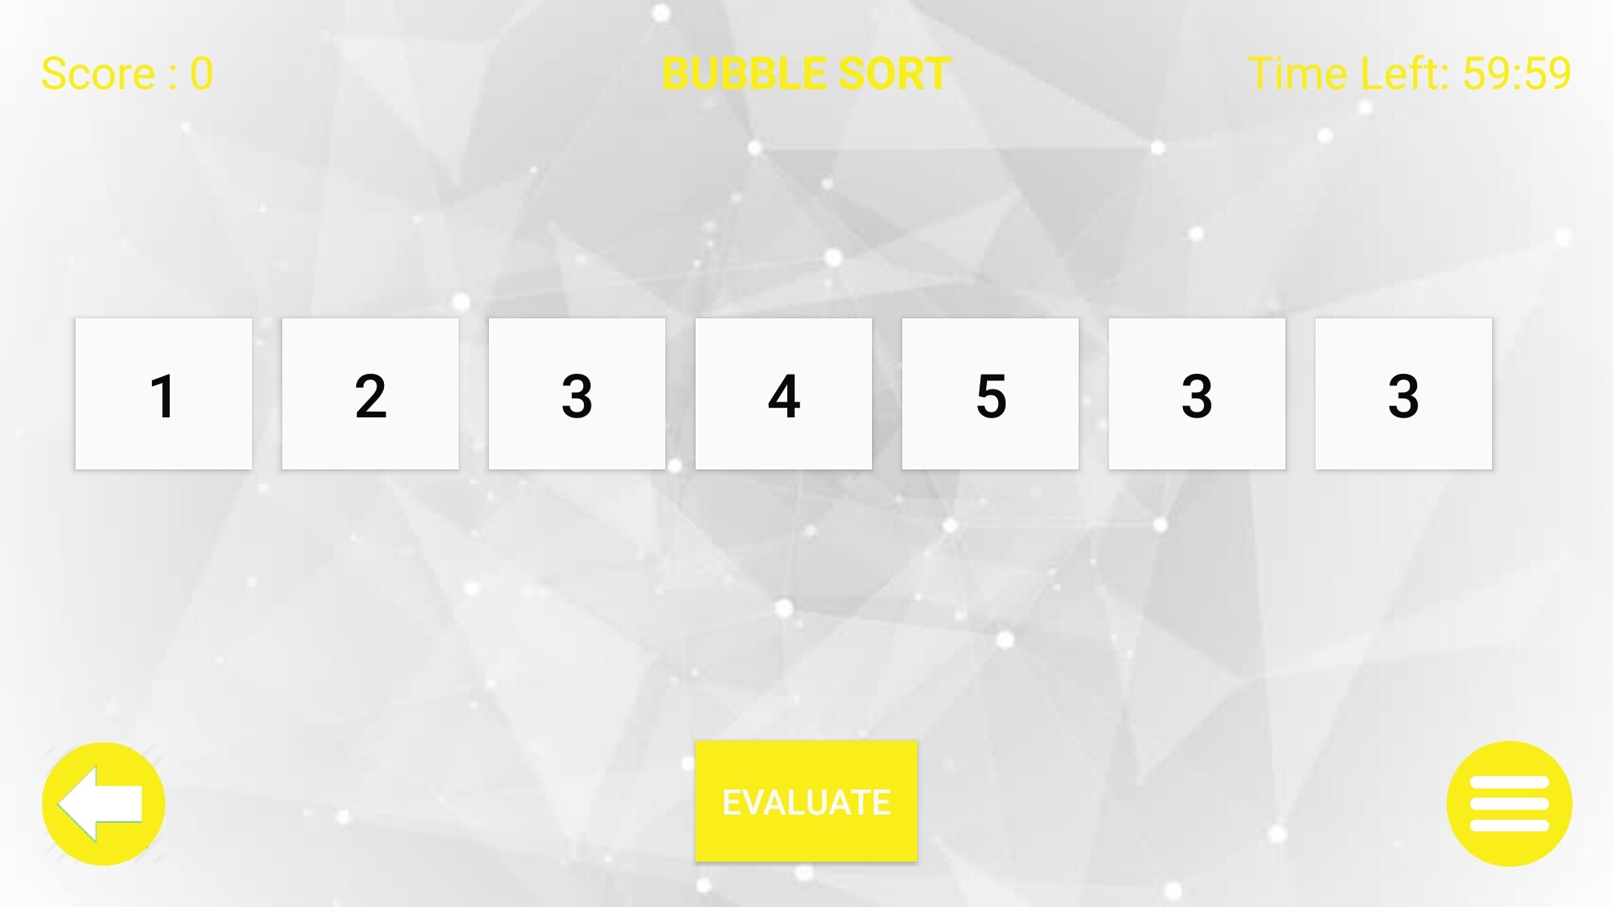

|  |  |  |  |  |  |  |
| --- | --- | --- | --- | --- | --- | --- |
| **Description of step.** | **Did the**  **user try**  **to**  **achieve**  **the end**  **goal or**  **did he**  **give up**  **At the**  **start**  **itself.** | **Did the user**  **notice that**  **the correct**  **action**  **choices are**  **available.**  **Yes –**  **PARTLY-No** | **Did the user**  **confidently**  **know that the**  **choice being**  **made by**  **him/her is**  **the right one**  **?**  **Y N** | **Did the user**  **understand**  **the**  **feedback**  **after every**  **action** | **Did the**  **user**  **Complete**  **the Task**  **With**  **Satisfaction**  **Yes**  **PARTLY**  **No** | **Comments**  **/**  **Alternative**  **suggestion**  **s/ solutions**  **/**  **discussion**  **points.** |
| A1:  Activate the app interface | **YES** | **PARTLY** | **NO** | **YES** | **YES** | **Though the interface was image friendly user being a novice was not confident** |
| A2:  Pressed “SETTINGS” button and then “How to play” to know the moves | **YES** | **YES** | **YES** | **YES** | **YES** |  |
| A3:  Pressed “Play Bubble sort” button and start playing the game | **YES** | **YES** | **YES** | **YES** | **YES** |  |
| A4:  Touch the cubes according to the Bubble sort algorithm and swap them | **PARTLY** | **YES** | **NO** | **YES** | **PARTLY** | **During the initial phase the user was not much confident but after 1 to 2 iterations user’s play was as expected.** |
| A5:  Press the “Evaluate” button to check the configuration at the end of outer loop and keep doing this until game is finished | **YES** | **YES** | **YES** | **YES** | **YES** |  |

**Analysis & Inference**

|  |  |  |  |
| --- | --- | --- | --- |
| **Action in Sequence** | **System mismatch Question** | **Potential problem and design solution** | **% Mismatch**  **to ideal**  **situation**  **(qualitative**  **estimation)** |
| A1:  Activate the app interface | Is it clear to the user that system  has taken input | **Low level game sound. Hence not much clear.** | **15 - 20%** |
| Can the user resume control for  the next action | **Almost confidently** |
| Are the systems response visible & interpretable | **System being image friendly responses are pretty clear** |
| Is the end of the system action  Clear | **Yes** |
| A2:  Pressed “SETTINGS” button and then “How to play” to know the moves | Is it clear to the user that system  has taken input | **Yes** | **5 - 10%** |
| Can the user resume control for  the next action | **Yes** |
| Are the systems response visible & interpretable | **Yes** |
| Is the end of the system action  Clear | **No. Clear instruction should have been mentioned** |
| A3:  Pressed “Play Bubble sort” button and start playing the game | Is it clear to the user that system  has taken input | **Yes** | **0 - 5%** |
| Can the user resume control for  the next action | **Yes** |
| Are the systems response visible & interpretable | **Yes** |
| Is the end of the system action  Clear | **Yes** |
| A4:  Touch the cubes according to the Bubble sort algorithm and swap them | Is it clear to the user that system  has taken input | **Need to include proper comments** | **20 - 30%** |
| Can the user resume control for  the next action | **Yes** |
| Are the systems response visible & interpretable | **Need to be more creative as interpretation is not clear.** |
| Is the end of the system action  Clear | **Yes** |
| A5:  Press the “Evaluate” button to check the configuration at the end of outer loop and keep doing this until game is finished | Is it clear to the user that system  has taken input | **Yes** | **0 - 5%** |
| Can the user resume control for  the next action | **Yes** |
| Are the systems response visible & interpretable | **Yes** |
| Is the end of the system action  Clear | **Yes** |

**Task – 2: Learning Insertion Sort by playing the game (user – Intermediate)**

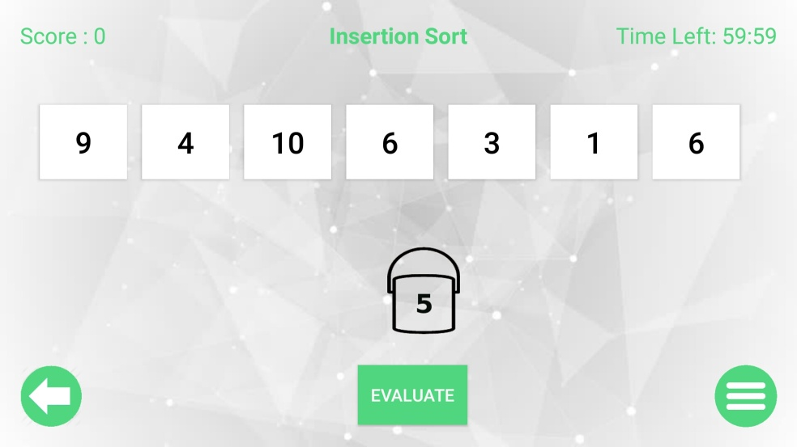

|  |  |  |  |  |  |  |
| --- | --- | --- | --- | --- | --- | --- |
| **Description of step.** | **Did the**  **user try**  **to**  **achieve**  **the end**  **goal or**  **did he**  **give up**  **At the**  **start**  **itself.** | **Did the user**  **notice that**  **the correct**  **action**  **choices are**  **available.**  **Yes –**  **PARTLY-No** | **Did the user**  **confidently**  **know that the**  **choice being**  **made by**  **him/her is**  **the right one**  **?**  **Y N** | **Did the user**  **understand**  **the**  **feedback**  **after every**  **action** | **Did the**  **user**  **Complete**  **the Task**  **With**  **Satisfaction**  **Yes**  **PARTLY**  **No** | **Comments**  **/**  **Alternative**  **suggestion**  **s/ solutions**  **/**  **discussion**  **points.** |
| A1:  Activate the app interface | **YES** | **YES** | **YES** | **YES** | **YES** |  |
| A2:  Pressed “SETTINGS” button and then “How to play” to know the moves | **NO** | **NO** | **NO** | **NO** | **NO** | **User being a intermediate started playing the game without instructions.** |
| A3:  Pressed “Play Insertion sort” button and start playing the game | **YES** | **YES** | **YES** | **YES** | **YES** |  |
| A4:  Touch the cube according to the Insertion sort algorithm and remove it from the list  Then place this cube correctly as per the Insertion sort into the list | **PARTLY** | **YES** | **NO** | **YES** | **PARTLY** | **During the initial phase the user was no much confident but he managed to play well afterwards** |
| A5:  Press the “Evaluate” button to check the configuration at the end of outer loop and keep doing this until game is finished | **YES** | **YES** | **YES** | **YES** | **YES** |  |

**Analysis & Inference**

|  |  |  |  |
| --- | --- | --- | --- |
| **Action in Sequence** | **System mismatch Question** | **Potential problem and design solution** | **% Mismatch**  **to ideal**  **situation**  **(qualitative**  **estimation)** |
| A1:  Activate the app interface | Is it clear to the user that system  has taken input | **Yes** | **10 - 15%** |
| Can the user resume control for  the next action | **Almost confidently** |
| Are the systems response visible & interpretable | **System being image friendly responses are pretty clear** |
| Is the end of the system action  Clear | **Yes** |
| A2:  Pressed “SETTINGS” button and then “How to play” to know the moves | Is it clear to the user that system  has taken input | **User being a intermediate did not play this move still he managed to complete the game.** | **90-100%** |
| Can the user resume control for  the next action |
| Are the systems response visible & interpretable |
| Is the end of the system action  Clear |
| A3:  Pressed “Play Insertion sort” button and start playing the game | Is it clear to the user that system  has taken input | **Yes** | **0 - 5%** |
| Can the user resume control for  the next action | **Yes** |
| Are the systems response visible & interpretable | **Yes** |
| Is the end of the system action  Clear | **Yes** |
| A4:  Touch the cube according to the Insertion sort algorithm and remove it from the list  Then place this cube correctly as per the Insertion sort into the list | Is it clear to the user that system  has taken input | **Need to include proper comments** | **20 - 30%** |
| Can the user resume control for  the next action | **Yes** |
| Are the systems response visible & interpretable | **Need to be more creative as interpretation is not clear.** |
| Is the end of the system action  Clear | **Yes** |
| A5:  Press the “Evaluate” button to check the configuration at the end of outer loop and keep doing this until game is finished | Is it clear to the user that system  has taken input | **Yes** | **0 - 5%** |
| Can the user resume control for  the next action | **Yes** |
| Are the systems response visible & interpretable | **Yes** |
| Is the end of the system action  Clear | **Yes** |

**Task – 3: Learning Selection Sort by playing the game (user – Expert)**

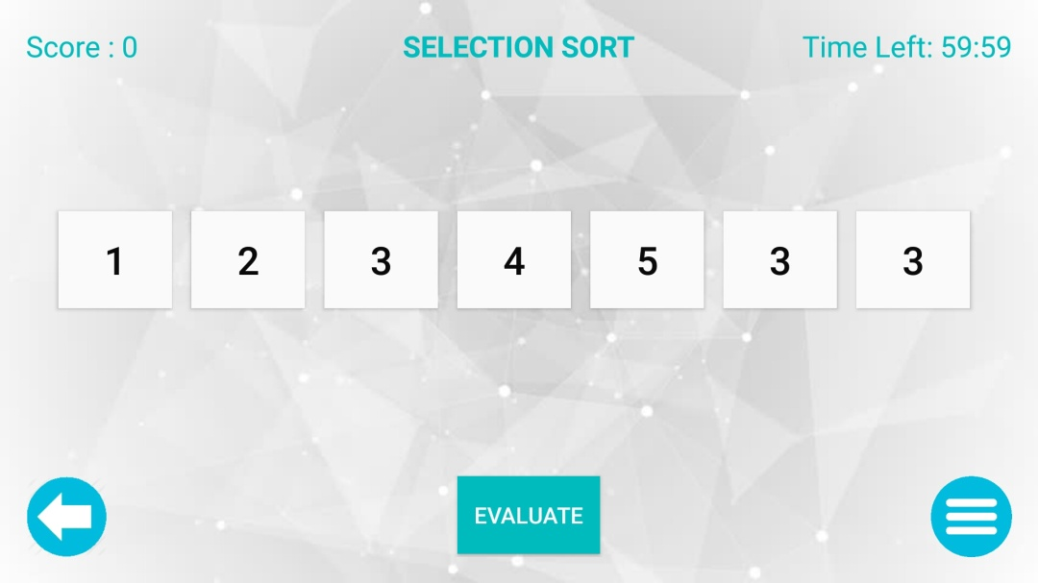

|  |  |  |  |  |  |  |
| --- | --- | --- | --- | --- | --- | --- |
| **Description of step.** | **Did the**  **user try**  **to**  **achieve**  **the end**  **goal or**  **did he**  **give up**  **At the**  **start**  **itself.** | **Did the user**  **notice that**  **the correct**  **action**  **choices are**  **available.**  **Yes –**  **PARTLY-No** | **Did the user**  **confidently**  **know that the**  **choice being**  **made by**  **him/her is**  **the right one**  **?**  **Y N** | **Did the user**  **understand**  **the**  **feedback**  **after every**  **action** | **Did the**  **user**  **Complete**  **the Task**  **With**  **Satisfaction**  **Yes**  **PARTLY**  **No** | **Comments**  **/**  **Alternative**  **suggestion**  **s/ solutions**  **/**  **discussion**  **points.** |
| A1:  Activate the app interface | **YES** | **YES** | **YES** | **YES** | **YES** |  |
| A2:  Pressed “SETTINGS” button and then “How to play” to know the moves | **NO** | **NO** | **NO** | **NO** | **NO** | **User being a expert started playing the game without instructions.** |
| A3:  Pressed “Play Selection sort” button and start playing the game | **YES** | **YES** | **YES** | **YES** | **YES** |  |
| A4:  Touch the cubes according to the selection sort algorithm and swap them | **YES** | **YES** | **YES** | **YES** | **YES** |  |
| A5:  Press the “Evaluate” button to check the configuration at the end of outer loop and keep doing this until game is finished | **YES** | **YES** | **YES** | **YES** | **YES** |  |

**Analysis & Inference**

|  |  |  |  |
| --- | --- | --- | --- |
| **Action in Sequence** | **System mismatch Question** | **Potential problem and design solution** | **% Mismatch**  **to ideal**  **situation**  **(qualitative**  **estimation)** |
| A1:  Activate the app interface | Is it clear to the user that system  has taken input | **Yes** | **10 - 15%** |
| Can the user resume control for  the next action | **Almost confidently** |
| Are the systems response visible & interpretable | **System being image friendly responses are pretty clear** |
| Is the end of the system action  Clear | **Yes** |
| A2:  Pressed “SETTINGS” button and then “How to play” to know the moves | Is it clear to the user that system  has taken input | **User being a expert did not play this move and completed the game successfully** | **90- 100%** |
| Can the user resume control for  the next action |
| Are the systems response visible & interpretable |
| Is the end of the system action  Clear |
| A3:  Pressed “Play Selection sort” button and start playing the game | Is it clear to the user that system  has taken input | **Yes** | **0 - 5%** |
| Can the user resume control for  the next action | **Yes** |
| Are the systems response visible & interpretable | **Yes** |
| Is the end of the system action  Clear | **Yes** |
| A4:  Touch the cubes according to the selection sort algorithm and swap them | Is it clear to the user that system  has taken input | **Yes** | **0- 10%** |
| Can the user resume control for  the next action | **Yes** |
| Are the systems response visible & interpretable | **Yes** |
| Is the end of the system action  Clear | **Yes** |
| A5:  Press the “Evaluate” button to check the configuration at the end of outer loop and keep doing this until game is finished | Is it clear to the user that system  has taken input | **Yes** | **0- 5%** |
| Can the user resume control for  the next action | **Yes** |
| Are the systems response visible & interpretable | **Yes** |
| Is the end of the system action  Clear | **Yes** |

**Task – 4: Learning Radix Sort by playing the game (user – Expert)**

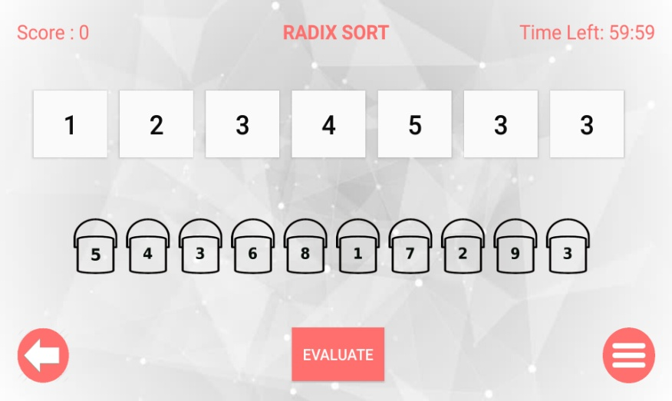

|  |  |  |  |  |  |  |
| --- | --- | --- | --- | --- | --- | --- |
| **Description of step.** | **Did the**  **user try**  **to**  **achieve**  **the end**  **goal or**  **did he**  **give up**  **At the**  **start**  **itself.** | **Did the user**  **notice that**  **the correct**  **action**  **choices are**  **available.**  **Yes –**  **PARTLY-No** | **Did the user**  **confidently**  **know that the**  **choice being**  **made by**  **him/her is**  **the right one**  **?**  **Y N** | **Did the user**  **understand**  **the**  **feedback**  **after every**  **action** | **Did the**  **user**  **Complete**  **the Task**  **With**  **Satisfaction**  **Yes**  **PARTLY**  **No** | **Comments**  **/**  **Alternative**  **suggestion**  **s/ solutions**  **/**  **discussion**  **points.** |
| A1:  Activate the app interface | **YES** | **YES** | **YES** | **YES** | **YES** |  |
| A2:  Pressed “SETTINGS” button and then “How to play” to know the moves | **YES** | **YES** | **YES** | **YES** | **YES** |  |
| A3:  Pressed “Play Radix sort” button and start playing the game | **YES** | **YES** | **YES** | **YES** | **YES** |  |
| A4:  Place the cubes into correct buckets according to the radix sort algorithm and place them back into correct position as per RADIX sort algorithm | **YES** | **YES** | **NO** | **PATLY** | **YES** | **It seemed that user has not followed the tutorial properly.** |
| A5:  Press the “Evaluate” button to check the configuration at the end of outer loop and keep doing this until game is finished | **YES** | **YES** | **NO** | **YES** | **NO** | **User looked pretty confused**  **About evaluating the moves after every loop iteration** |

**Analysis & Inference**

|  |  |  |  |
| --- | --- | --- | --- |
| **Action in Sequence** | **System mismatch Question** | **Potential problem and design solution** | **% Mismatch**  **to ideal**  **situation**  **(qualitative**  **estimation)** |
| A1:  Activate the app interface | Is it clear to the user that system  has taken input | **Yes** | **10 - 15%** |
| Can the user resume control for  the next action | **Almost confidently** |
| Are the systems response visible & interpretable | **System being image friendly responses are pretty clear** |
| Is the end of the system action  Clear | **Yes** |
| A2:  Pressed “SETTINGS” button and then “How to play” to know the moves | Is it clear to the user that system  has taken input | **Yes** | **0-5%** |
| Can the user resume control for  the next action | **Yes** |
| Are the systems response visible & interpretable | **Yes** |
| Is the end of the system action  Clear | **Yes** |
| A3:  Pressed “Play Radix sort” button and start playing the game | Is it clear to the user that system  has taken input | **Yes** | **0 - 5%** |
| Can the user resume control for  the next action | **Yes** |
| Are the systems response visible & interpretable | **Yes** |
| Is the end of the system action  Clear | **Yes** |
| A4:  Place the cubes into correct buckets according to the radix sort algorithm and place them back into correct position as per RADIX sort algorithm | Is it clear to the user that system  has taken input | **Yes** | **20- 25%** |
| Can the user resume control for  the next action | **No. Probably the buttons and instructions should be more clear** |
| Are the systems response visible & interpretable | **Yes** |
| Is the end of the system action  Clear | **Partly** |
| A5:  Press the “Evaluate” button to check the configuration at the end of outer loop and keep doing this until game is finished | Is it clear to the user that system  has taken input | **Yes** | **30-35%** |
| Can the user resume control for  the next action | **No. User interface for evaluator button must be more clear** |
| Are the systems response visible & interpretable | **Partly** |
| Is the end of the system action  Clear | **Partly** |

**Task – 5: Checking the highest score (user – Expert)**

|  |  |  |  |  |  |  |
| --- | --- | --- | --- | --- | --- | --- |
| **Description of step.** | **Did the**  **user try**  **to**  **achieve**  **the end**  **goal or**  **did he**  **give up**  **At the**  **start**  **itself.** | **Did the user**  **notice that**  **the correct**  **action**  **choices are**  **available.**  **Yes –**  **PARTLY-No** | **Did the user**  **confidently**  **know that the**  **choice being**  **made by**  **him/her is**  **the right one**  **?**  **Y N** | **Did the user**  **understand**  **the**  **feedback**  **after every**  **action** | **Did the**  **user**  **Complete**  **the Task**  **With**  **Satisfaction**  **Yes**  **PARTLY**  **No** | **Comments**  **/**  **Alternative**  **suggestion**  **s/ solutions**  **/**  **discussion**  **points.** |
| A1:  Activate the app interface | **YES** | **YES** | **YES** | **YES** | **YES** |  |
| A2:  Press the “LEADERBOARD” button to see the top 5 highest scores | **YES** | **YES** | **YES** | **YES** | **YES** |  |

**Analysis & Inference**

|  |  |  |  |
| --- | --- | --- | --- |
| **Action in Sequence** | **System mismatch Question** | **Potential problem and design solution** | **% Mismatch**  **to ideal**  **situation**  **(qualitative**  **estimation)** |
| A1:  Activate the app interface | Is it clear to the user that system  has taken input | **Yes** | **0 - 5%** |
| Can the user resume control for  the next action | **Almost confidently** |
| Are the systems response visible & interpretable | **System being image friendly responses are pretty clear** |
| Is the end of the system action  Clear | **Yes** |
| A2:  Press the “LEADERBOARD” button to see the top 5 highest scores | Is it clear to the user that system  has taken input | **Yes** | **0-5%** |
| Can the user resume control for  the next action | **Yes** |
| Are the systems response visible & interpretable | **Yes** |
| Is the end of the system action  Clear | **Yes** |

**Task – 6: Increasing/decreasing the game sound (user – Expert)**

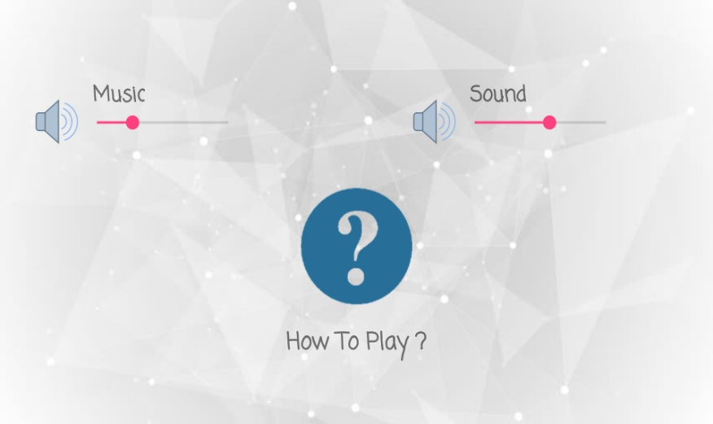

|  |  |  |  |  |  |  |
| --- | --- | --- | --- | --- | --- | --- |
| **Description of step.** | **Did the**  **user try**  **to**  **achieve**  **the end**  **goal or**  **did he**  **give up**  **At the**  **start**  **itself.** | **Did the user**  **notice that**  **the correct**  **action**  **choices are**  **available.**  **Yes –**  **PARTLY-No** | **Did the user**  **confidently**  **know that the**  **choice being**  **made by**  **him/her is**  **the right one**  **?**  **Y N** | **Did the user**  **understand**  **the**  **feedback**  **after every**  **action** | **Did the**  **user**  **Complete**  **the Task**  **With**  **Satisfaction**  **Yes**  **PARTLY**  **No** | **Comments**  **/**  **Alternative**  **suggestion**  **s/ solutions**  **/**  **discussion**  **points.** |
| A1:  Activate the app interface | **YES** | **YES** | **YES** | **YES** | **YES** |  |
| A2:  Press the SETTINGS button and repeatedly press the increase/decrease volume button to increase/decrease the game sound. | **YES** | **PATLY** | **NO** | **YES** | **YES** | **User was not given instruction about how to increase or decrease the volume.** |

**Analysis & Inference**

|  |  |  |  |
| --- | --- | --- | --- |
| **Action in Sequence** | **System mismatch Question** | **Potential problem and design solution** | **% Mismatch**  **to ideal**  **situation**  **(qualitative**  **estimation)** |
| A1:  Activate the app interface | Is it clear to the user that system  has taken input | **Yes** | **0 - 5%** |
| Can the user resume control for  the next action | **Almost confidently** |
| Are the systems response visible & interpretable | **System being image friendly responses are pretty clear** |
| Is the end of the system action  Clear | **Yes** |
| A2:  Press the SETTINGS button and repeatedly press the increase/decrease volume button to increase/decrease the game sound. | Is it clear to the user that system  has taken input | **Yes** | **10-20%** |
| Can the user resume control for  the next action | **No. “+” / ”-“ options should be provided along with sliding option** |
| Are the systems response visible & interpretable | **Yes** |
| Is the end of the system action  Clear | **Yes** |

**Summary:**

After compilation of all the Analysis and Inference reports from all the team members following conclusions were made:-

1) Improving the touch interface of bubble and insertion sort so that they are more user friendly.

2) Improving on the buckets in Radix sort so that user can view the buckets correctly

3) Proper instructions about increasing and decreasing the volume and music of the game must be provided.

4) Clearly indicate the use of evaluator button to smoothen the sorting process.

5) Proper sound on starting of app interface to indicate the initialization of app.

6) Clear instructions must be given at the end of game to go back to main menu.